Fill in the opposite to the underlined words below.
young | big
sour | night-time
awake | dirty
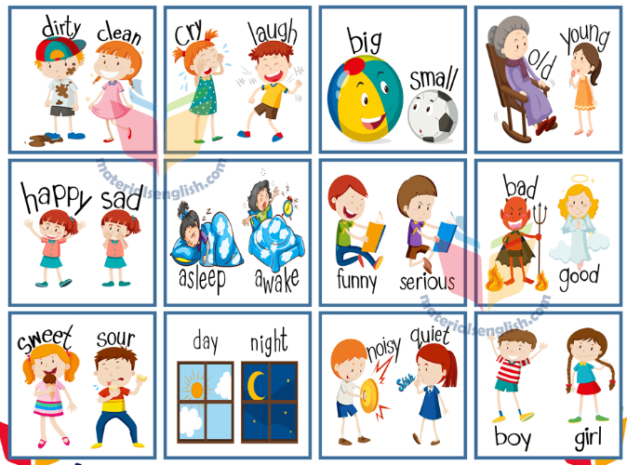
Opposites

Andrew was asleep but Jophina was _________.
Rory’s hurling boots were clean but Liam’s boots were __________.
Harry’s dog was old and Tommy’s dog was ___________.
Pixie loves the daytime and Dan loves the ____________.
Roisin loves jellies that are sweet but Sean loves jellies that are ___________.
Robbie has a small sister and Andrew has a _________ sister.

