St. Canice’s Co-Ed.
Anti-Bullying Campaign

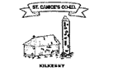
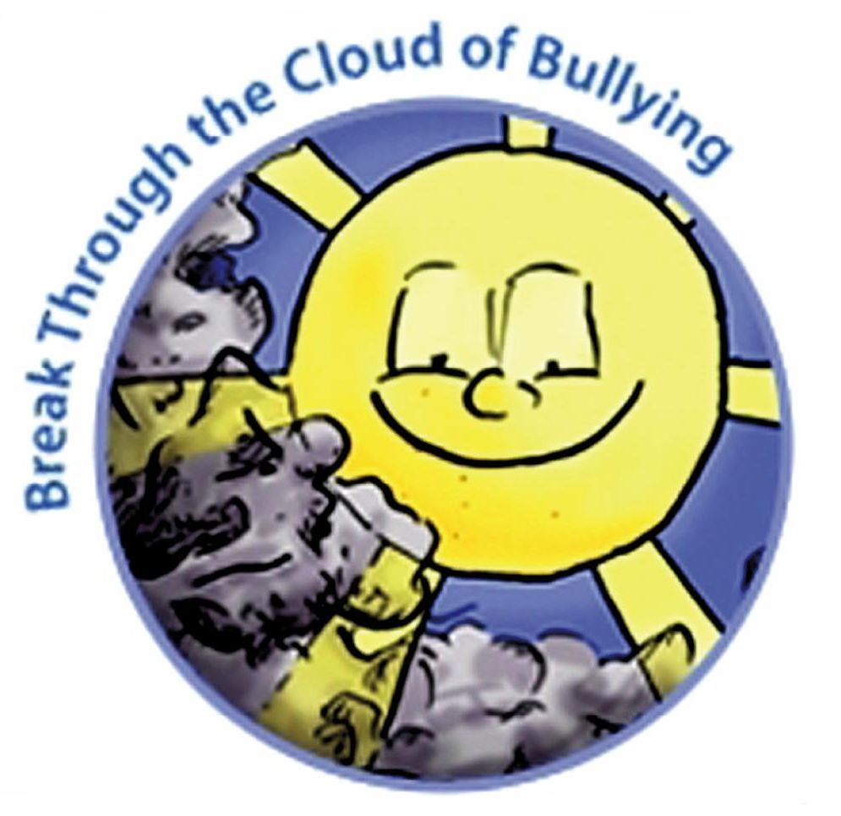

Anti-bullying Survey - Senior Infants

Class Survey to be completed in circle time format

- What makes you happy in the yard?

- What can make you feel sad in the yard?

- Is our classroom a happy place?

- What kind of things make our classroom happy?

- What would we do if something happened that made us feel sad?

- Who can we tell in school if someone/something makes us sad?

