**St Canice’s Co Ed N.S.**

**First Class Survey**

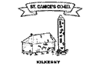

Here



  

**A lot**  **Sometimes** **Not much**

1. I like my school.

  

1. I have some special friends at school.

  

1. I like to play in the playground.

  

1. The other boys and girls are nice to me.

  

1. If I am unhappy at school I tell an adult.

  