Sounds  1 | Double Double!  2 | oa words  3
Days of the Week  4 | 3-D Shape Hunt  5 | Dolch Stars!  6
Number Rumble  7 | Toy Cars  8 | 2D shapes  9
fr words  10 | Guess!  11 | Listen Listen!  12
Acrostic Poem  13 | DEAR Time!  14 | FINISHED 😊
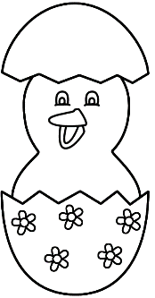
First Class
Numeracy and Literacy Activities

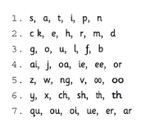
- Sounds
(Aim: To revise the Jolly Phonics sounds.)
Say your sounds. You know them and are super at them. Well done!

2.Double Double!
(Aim- Continue to learn our doubles as we work towards knowing them very quickly!)

Your parent will call a number and you have to double it. How many can you do in one minute?
Numbers 1-10
(1+1=2 2+2= 4 3+3=6 4+4=8 5+5=10 6+6=12 7+7=14 8+8=16 9+9=18 10+10=20)

If you are very quick at them, try some near doubles.
(6+7= 13 9+8=17 4+5=9 8+7=15)

- The oa word challenge!
(Aim: to revise the oa sound)
You have 2 minutes.
How many oa words can you think of? You could make it a challenge with your parent! We think you will win for sure!
Here are 2 words to get you started: goat, bloated
Good luck!

- Days of the Week
(Aim: To know the days of the week and order them)
We have the days of week in the wrong order. Can you order them correctly for us?

Tuesday, Sunday, Wednesday, Friday, Monday, Saturday, Thursday
How many of the days can you spell?
What is your favourite day of the week? Why?

- 3-D Shape Hunt
(Aim: to name 3-D shapes)
We are very good at 3D shapes.
Look at the pictures below. Can you do a little shape hunt in your house with your parent? Can you find 3 things for each shape? For example: A ball is a sphere shape.
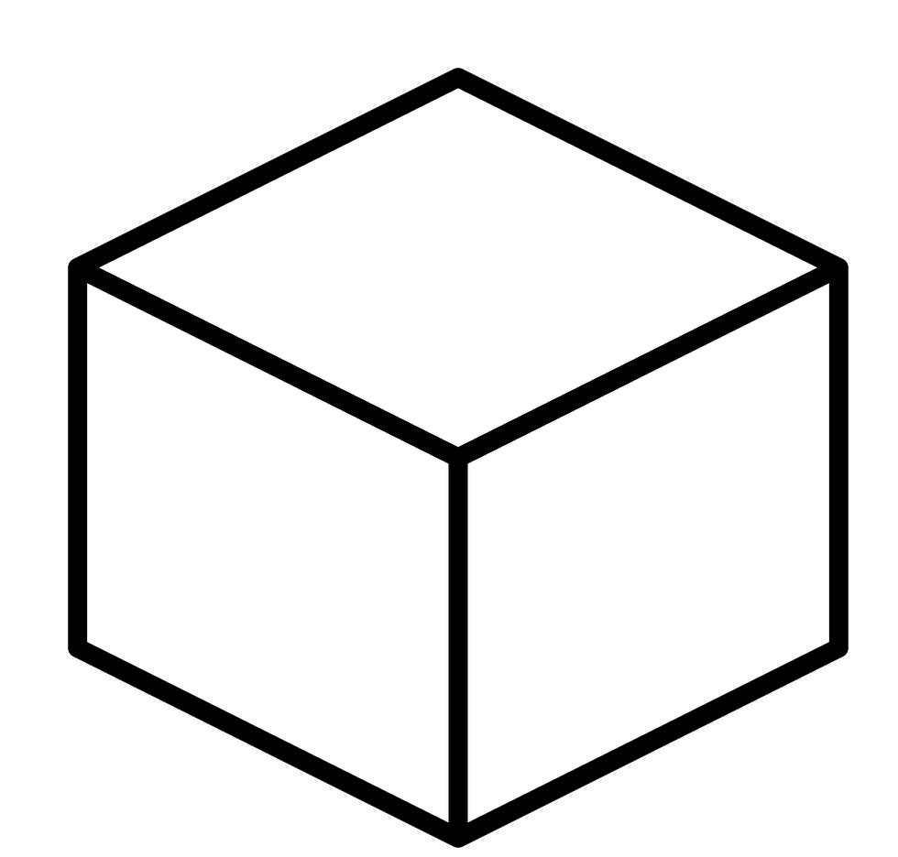 Cube | Sphere  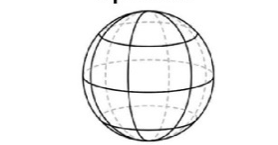
Cuboid | Cylinder

- Dolch Stars!
(Aim- to know our common words )
Play Bingo with the Dolch words
One person calls the words and the others colour them/ put a counter on them. Whoever fills the card first is the winner! I have to warn you parents, the children are really good at this- there is a huge chance they will win!

bring | once | she
drink | goes | right

soon | made | try
gave | keep | much

- Number Rumble

(Aim: to know the number before/ after numbers, within 100)
Sometimes the number before can be a little trickier.
Write a selection of numbers on paper and cut up.
Put them in a tub.
Your child closes their eyes and takes out a card.
Challenge- can you tell me the number before or after this number?
For example 36.
35 is before and 37 is after.
How many can you do in a minute?
Try again! Can you beat your score?

- Toy Car Race
(Aim: To practice using the words first/second/third/ fourth /fifth /next/last/between)
Find 5 toy cars and race them on the floor.
Which car came first?
Which came third?
Which car was last?
Which car was next?
Which car was second?

9. 2-D Shapes
(Aim: To revise 2-D shapes )
- Can you draw these shapes?
Circle, square, rectangle, triangle, semi-circle.
- Draw a picture using just these shapes.
- Use your imagination!
- Have fun!

10. fr Words

Can you read the silly sentences with fr words?
Freddie frog fried french fries for his lunch on Friday!
Freda and Frank are friends with Fred and Mary French.

That is a lot of fr sounds!
Can you make up a silly sentence with lots of fr words?

11. Guess!
What is my Number?
(Aim: To answer questions with maths language)
My number is before 66. Do you know it?
My number is after 78. What is it?
My number is between 45 and 47. What is it?
My number is less than 85 and more than 83, what is my number?
My number is an even number less than 20, but more than 10. It has 8 units. What do you think it is?

12. Listen Listen!
(Aim: To listen to and follow instructions)

This is fun!
You need a pencil and paper and some colours.
You need to listen really well!
Parent calls out instructions for child to follow.
For example:

- Draw a rectangle in the middle of the page.
- Draw a door in the middle of the rectangle.
- Draw two windows inside the rectangle, one each side of the door. Now it is a house!
- Draw 2 clouds in the sky.
- Draw a bird on top of the house.
- Draw a cat beside the house.
- Draw a tree with 4 apples on the other side of the house.
- Colour the house red and the cat yellow.
You can obviously change this to suit the interests of the child.
Check the drawing. How many instructions did you follow?
Well done!

13. Acrostic Poem
(Aim – To write for pleasure and for children to hear nice things about themselves.)
You can write a nice poem about your parent and they can write one for you!
For example:
If your name was Jack

Jack is always thoughtful.
Always giggling and making us smile.
Colourful personality, full of fun.
Kind to all and a wonderful son.

14. DEAR Time
Drop Everything And Read
Relax, choose a book and read with a parent. We hope you enjoy your story time!

