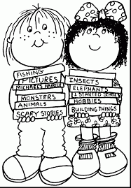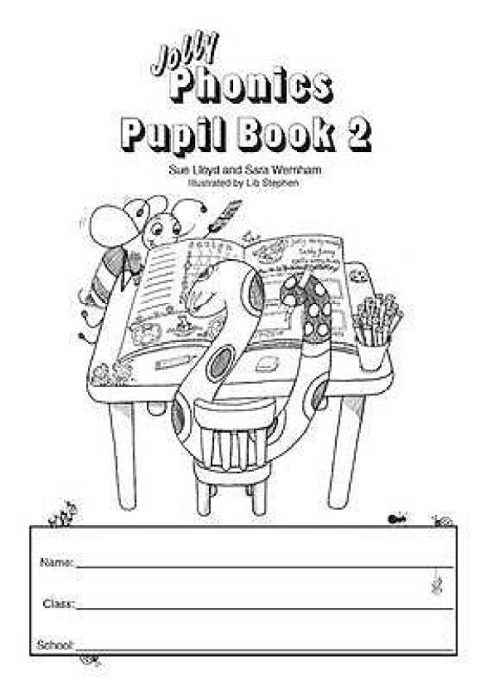BANG

BANG

**Finish**

get

BANG

test

mist

BANG

pram

hiss

kiss

BANG

hit

BANG

hat

camp

net

neck

can

hen

**start**

BANG

pet

mat

ran

BANG

dip

rap

hip